

**MANIPAL UNIVERSITY JAIPUR**

Faculty of Engineering | School of Computing and Intelligent Systems

**Department of IoT & IS**

**Session:** Jan 2024 – May 2024 | **Program:** B. Tech. IoT & IS | **Semester:** IV

**IS2201 Operating System**

# Group Assignment 2

Pranav Karwa 229311052, IOT - B

Aniruddha Bolakhe 229303199,

Hitesh Sangra 229302611,

Nabhya Sharma 229311118

# Process Scheduling

Consider the following source codes:

**program looptest**

**read(i)** **for n = 1 to 15** **x = i + n** **next**

**end**

Compile the above source code using **CPU-OS Simulator** and load it in the main memory and run this code. To enter the OS simulator:

1. Click on the OS O… button in the current window. The OS window opens.
2. You should see an entry titled as the program name given above, in the PROGRAM LIST view.
3. Now that this program is available to the OS simulator, we can create as many instances, i.e. processes, of it as we like. You do this by clicking on the CREATE NEW PROCESS button.

## PART-A

* Select the **First-Come-First-Served (FCFS)** option in the SCHEDULER/Policies view
* Time slice should be considered as **seconds.**
* Create four processes P1, P2, P3 and P4 from source code respectively (Use the

Priority drop-down list in the PROGRAM LIST / Process View): **3, 2, 4**,**1** ➢ Slide the Speed selector half‐way down and then hit the START button.

* **Arrival delay** should be considered in **seconds** in the OS simulator **Now, give answer for the following:**

1. What is the order in which processes are executed?

|  |
| --- |
| P1-P2-P3-P4 |

1. What is the ***Elapsed time , Average Process Waiting Time*** and ***Average Burst Period*** and of each process? (To see this, Click on VIEWS button available on the left of your OS control, the click VIEW LOG)

|  |  |  |  |  |
| --- | --- | --- | --- | --- |
| Process | ***Arrival***  ***Time/Delay*** | ***Elapsed Time***  ***(sec)*** | ***Average Process Waiting Time (sec)*** | ***Average Burst***  ***Period*** |
| P1 | 0 | 40.138 | 0.32 | 125 |
| P2 | 0 | 38.130 | 160.71 | 125 |
| P3 | 0 | 38.381 | 319.09 | 125 |
| P4 | 0 | 38.381 | 477.72 | 125 |
|  | Avg. Process Waiting Time | | | 239.46 |
|  |  | | |  |

## PART-B

* Select the **Shortest Job First (SJF)** option in the SCHEDULER/Policies view
* Select the Priority (static) as **Pre-emptive** option in the SCHEDULER/Policies view ➢ Time slice should be considered as **seconds.**
* Create four processes P1, P2, P3 and P4 from source codes respectively (Use the

Priority drop-down list in the PROGRAM LIST / Process View): **3, 2, 4**,**1** ➢ Slide the Speed selector half‐way down and then hit the START button.

* **Arrival delay** should be considered in **seconds** in the OS simulator **Now, give answer for the following:**

1. What is the order in which processes are executed?

|  |
| --- |
| P1-P2-P3-p4 |

1. What is the ***Elapsed time , Average Process Waiting Time*** and ***Average Burst Period*** and of each process? (To see this, Click on VIEWS button available on the left of your

OS control, the click VIEW LOG)

|  |  |  |  |  |
| --- | --- | --- | --- | --- |
| Process | ***Arrival***  ***Time/Delay*** | ***Elapsed Time***  ***(sec)*** | ***Average Process Waiting Time (sec)*** | ***Average Burst***  ***Period*** |
| P1 | 0 | 31.917 | 0.31 | 125 |
| P2 | 0 | 29.310 | 152.46 | 125 |
| P3 | 0 | 29.310 | 302.01 | 125 |
| P4 | 0 | 29.310 | 451.55 | 125 |
|  |  | Avg. Process Waiting Time = |  | 226.58 |

## PART-C

* Select the **Round Robin (RR) with 5 seconds as time slice** option in the SCHEDULER/Policies view.
* Select the Priority (static)as **Pre-emptive** option in the SCHEDULER/Policies view
* Time slice should be taken in terms of **seconds** instead of **ticks**
* Create four processes P1, P2, P3 and P4 from source codes respectively (Use the

Priority drop-down list in the PROGRAM LIST / Process View): **3, 2, 4**,**1** ➢ Slide the Speed selector half‐way down and then hit the START button.

* **Arrival delay** should be considered in **seconds** in the OS simulator **Now, give answer for the following:**

1. What is the order in which processes are executed?

|  |
| --- |
| P4-P2-P1-P3 |

1. What is the ***Elapsed time , Average Process Waiting Time*** and ***Average Burst Period*** and of each process? (To see this, Click on VIEWS button available on the left of your OS control, the click VIEW LOG)

|  |  |  |  |  |
| --- | --- | --- | --- | --- |
| Process | ***Arrival***  ***Time/Delay*** | ***Elapsed Time***  ***(sec)*** | ***Average Process Waiting Time (sec)*** | ***Average Burst Period*** |
| P1 | 0 | 36.657 | 10.15 | 3 |
| P2 | 0 | 36.894 | 5.09 | 3 |
| P3 | 0 | 29.311 | 474.31 | 125 |
| P4 | 0 | 39.739 | 0.24 | 3 |
|  | Avg. Process Waiting Time = | | | 166.23 |

## PART-D

1. Plot a graph from the results obtained by FCFS, SJF and Round Robin scheduling and explain which algorithm is better among these with proper justification.

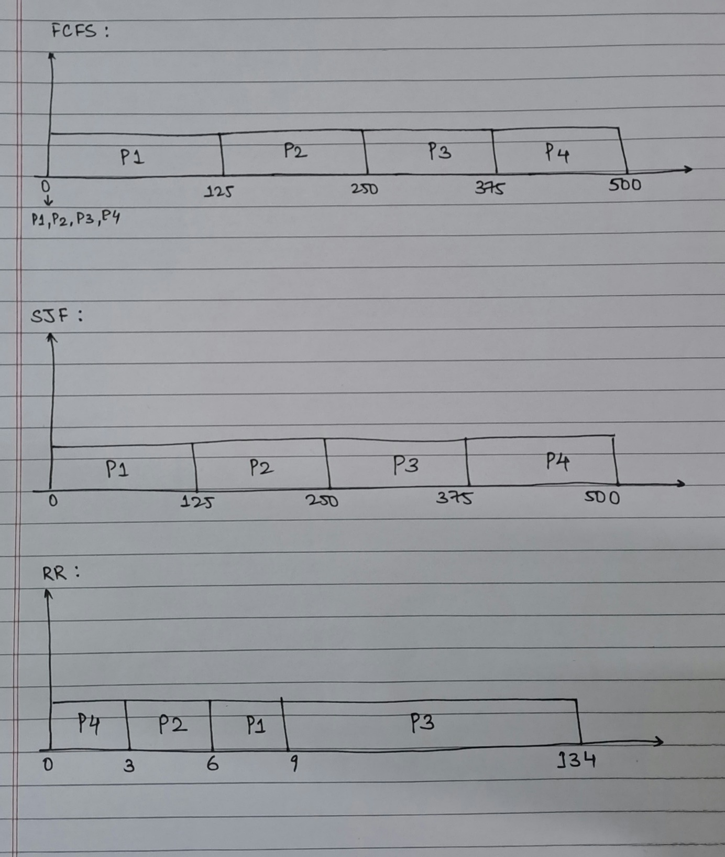

The best method to slove the problem is **Round Robin method** as it is having the least avg. waiting time.

ScreenShots

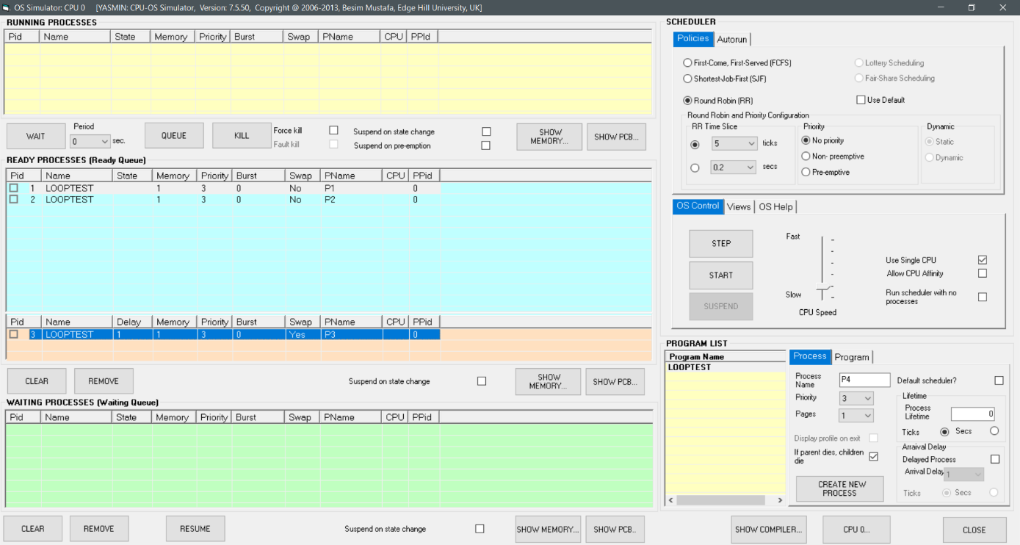

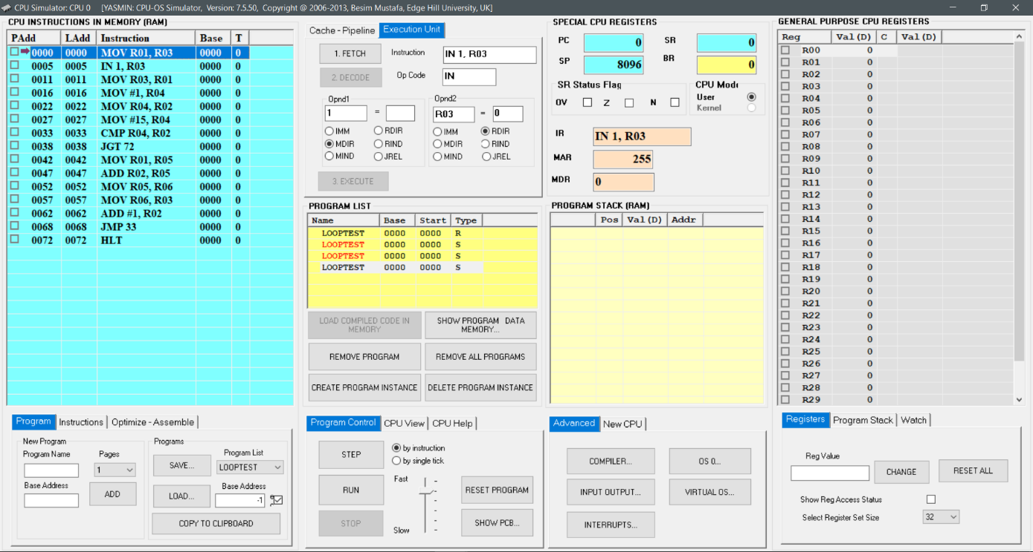

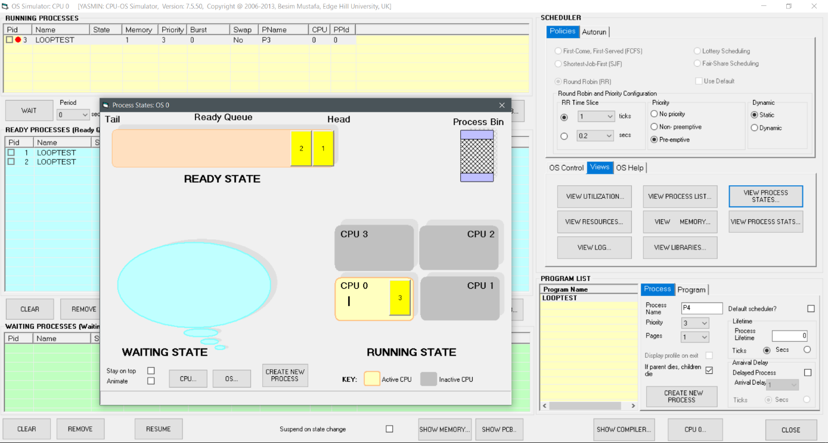

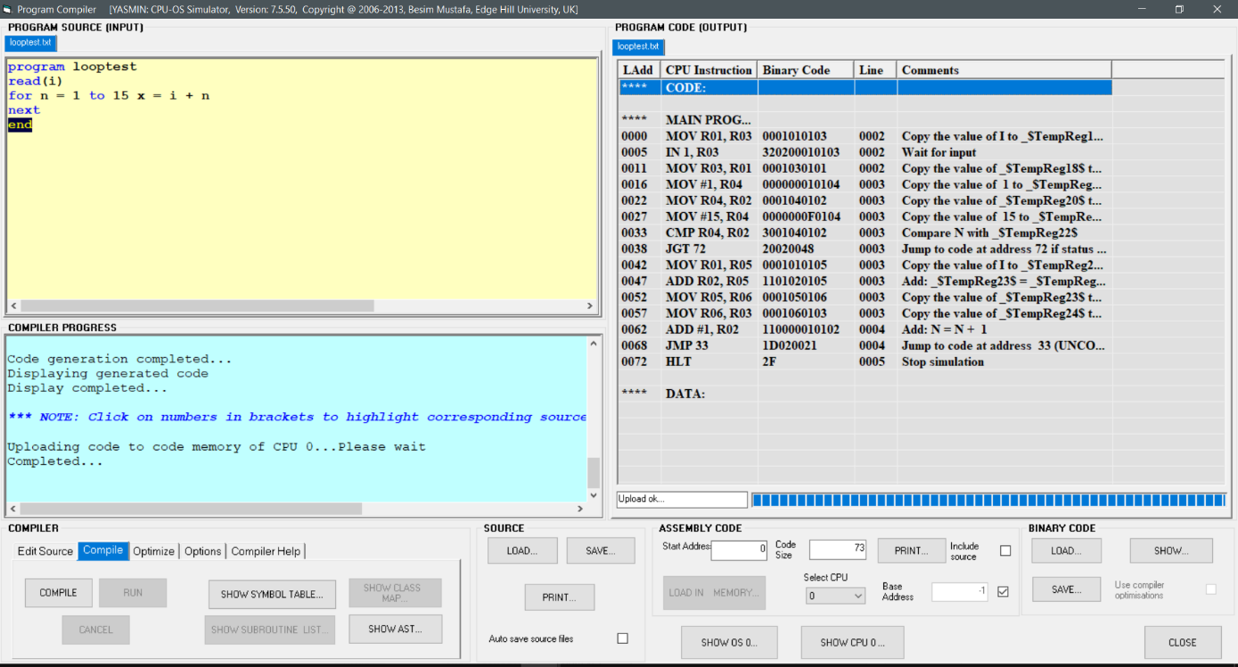

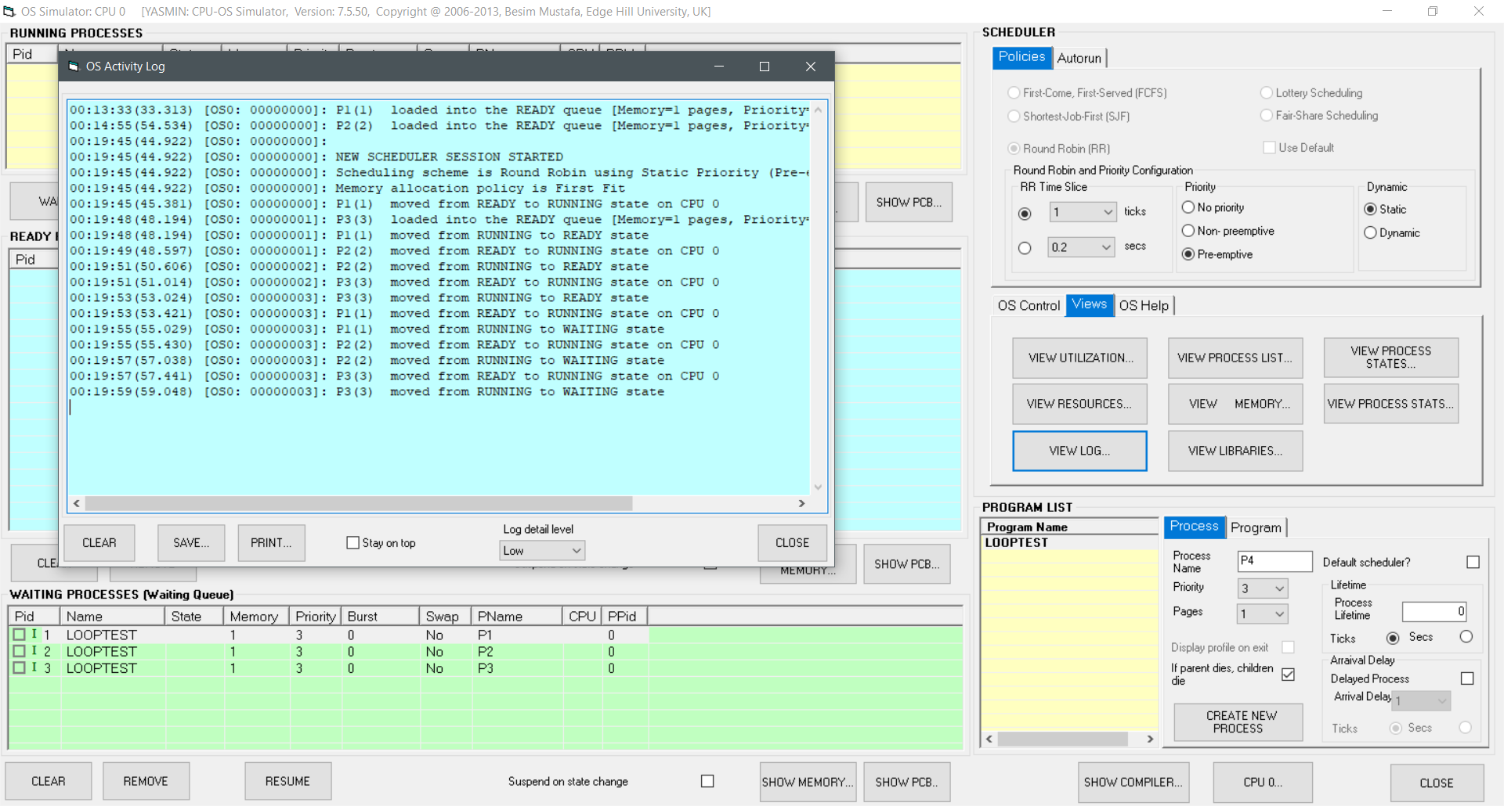

OUTPUTS

1] First Come First Serve

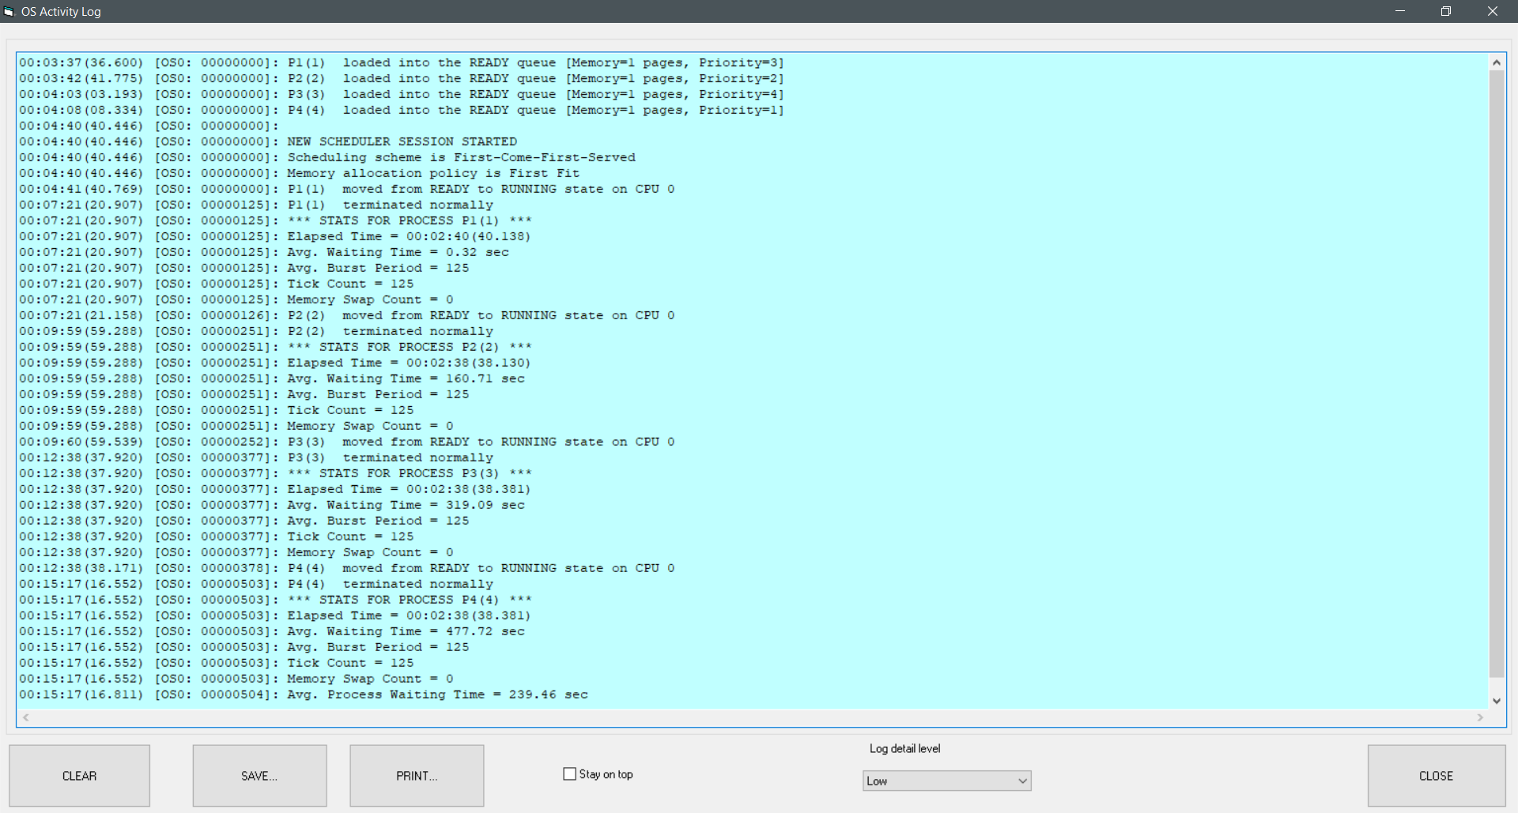

2]Shortest Job First

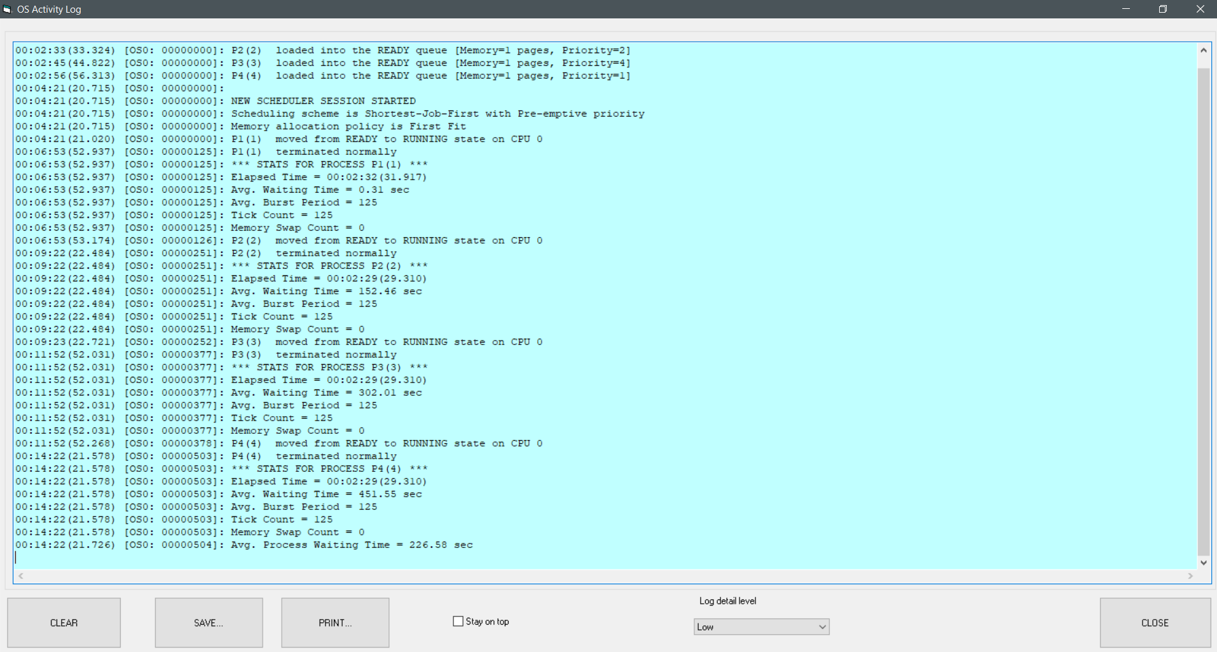

3]Round Robin

